SE4940 Final Exam Name _____Answer Man____________________

Open book. Work alone. Do not refer to prior exams (previous SE4940 sections or PhD qualifying practice tests). Due COB 19 June 2014

1. Given the differential equation  derive the equivalent system of first-order ordinary differential equations. This is a fourth order differential equation. What order is the system of equations? Is the system linear or nonlinear? What does such a system of first-order ordinary differential equations represent?

2. The Maxwell-Bloch equations are a sophisticated model for a laser and describe the dynamics of the electric field *E*, the mean polarization of the atoms *P*, and the population inversion *D*:







where **1 and **2 are decay rates of the atomic polarization and population inversion, respectively, and * *is a pumping energy parameter. The parameter ** may be positive, negative, or zero; all other parameters are positive. In the simplest case, *P* and *D* relax rapidly to steady values, and hence may be eliminated as follows.

1) Assuming  , express *P* and *D* in terms of *E*, and thereby derive a first-order equation for the evolution of *E*.

2) Find all the fixed points of *E*.

3) Draw the bifurcation diagram of *E*\* versus **. Distinguish between stable and unstable branches.

3. What is this an example of? What features are represented?

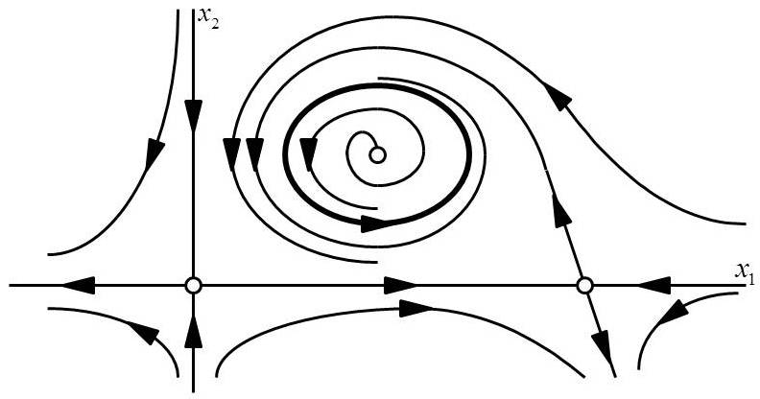

4. For the Lorenz equations







with ** = 10, *r* = 28, and *b* = 2.66666, and initial condition *x* = 1.0+**, *y* = 1.0, and *z* = 10, determine how long it takes the absolute error between the “true *x* solution” (** = 0) to grow from ** to 0.1. Calculate for ** values of 0.01, 10-4, 10-6, 10-8, and 10-10. What does this tell you about the predictability versus measurement error? Can you estimate the Liapunov exponent?

5. Consider the iterated map given by



where 0 < *r* < 2. What properties do you expect to see in the orbit diagram? Is there any condition that might cause different behavior? The Liapunov exponent is ** = ln *r*. What does this tell you about the behavior?

6. In your own words and using no more than one paragraph, describe the difference between complex and complicated systems. That is, in your own opinion what distinguishes the two?

7. How are fractals and complexity related?

8. Define what an adaptive agent-based model is and briefly describe its characteristics.

9. In an engineering system consisting of various parts and mechanisms, what kinds of diversity are most applicable to determining complexity? How might that diversity be measured?

10. What approaches are likely to part of any attempt to harness complexity in an inherently complex system?